**Part 1**

* As with every part of Assessment 2, you will login to the Linux Ubuntu virtual machine installed on the PC in the lab.
* Download this word document onto your H: drive in a folder created for this module and lab class. Save the file, changing the name of the file to YourNameA2Part1.docx.
* Now, you can open this file, answer the questions, save it, and finally upload to the correct area in Blackboard. Ask your lecturer where to submit your work, **make sure you submit in the correct area on Blackboard, for your lab lecturer**.
* You can use the **Snipping tool program** to make cut&paste, to copy extracts from your terminal sessions… into your document to help answer questions.

**Question 1**

*Show your understanding of directories (terminal view) and folders (desktop GUI view).*

Note: As with all QUESTIONS, do not forget to record your progress by copying your progress to your report. Save regularly. Please ask your lab lecturer if you have any questions or require assistance.

* Open a terminal.
* Use the **ls**, **ls – l**, and **pwd** command every so often where appropriate.
* Make sure you are in the home user directory, by typing **cd ~**, and then check with **pwd**.
* Make the directory called **Part1** by typing **mkdir Part1**. Next, change to this directory by typing **cd Part1**.
* Make 4 directories, choose your own 4 names. Display the contents of this directory Part1.

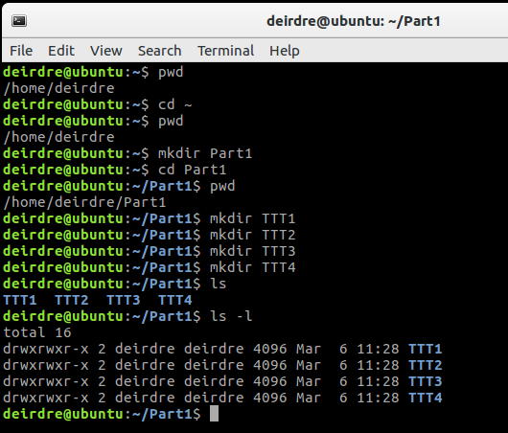

* Open the desktop graphical File Manager. Change to the Part 1 folder to show its contents.

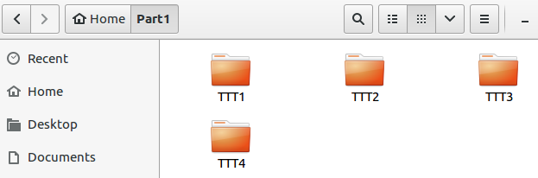

**Question 2**

*The root directory contains many directories. You must describe a selection of directories, and show examples where possible.*

Note: As with all QUESTIONS, you might need to use the **man** command to find out information about a command. You might need to open up the Notes/Slides on Blackboard – (*example: the slides from week 3 might be helpful*). Also, by opening a browser, you might be able to search for information that is helpful.

* Open a terminal.
* Change to the root directory of the file system. Type **cd /** and then type **pwd**. Type **ls**.
* By changing back and forth between the directories, listing files…., describe each of the following directories (a short clear description [around 6 lines for each directory] with example(s) where possible is required):

**/bin**

Contains binaries, a list of commands that you use to perform tasks, eg:

* Cat
* ls
* su

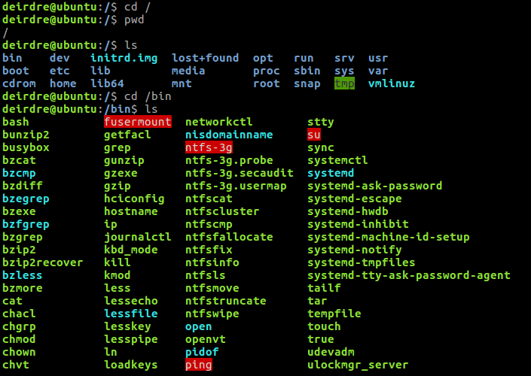

**/etc - For this directory, your example should refer to files passwd, shadow and group.**

Stores information about the users, eg:



one for each user, contains information about the user such as user id, home directory



contains the encryption of users’ passwords (can only be read by root)



lists groups and their group members

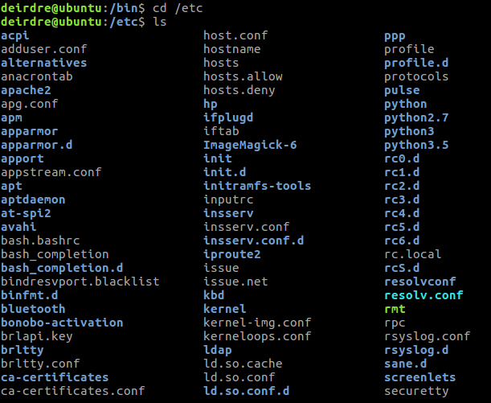

**/usr**

User’s directory shows files, games, library, etc

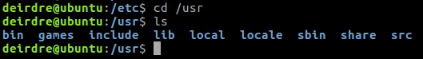

**/home**

Home folder individual to the user, stores the user’s own files, the default login directory

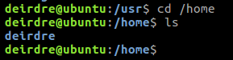

**Question 3**

*Show your understanding of terminal editors and graphical editors.*

* Open the terminal.
* Go to the Part1 directory.
* Create 3 sample short files of your own choice, however, you must use 1) the **nano** editor, 2) the **vi editor** and 3) the graphical editor program **gedit**.

1. Nano

Used to create a simple text file, has on-screen instructions on how to save, find text, cut/copy text

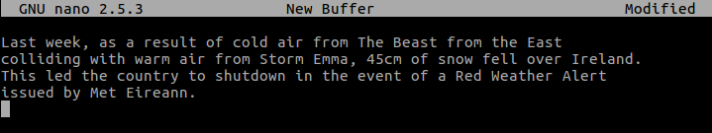

1. Vi editor

Used for commands, requires some knowledge

i start typing

ESC escape out of typing

:w save the file

:wq save and exit

:q quit file

:q! quit without saving

1. Gedit

Has a GUI interface, making it straightforward to create, edit, and save the file

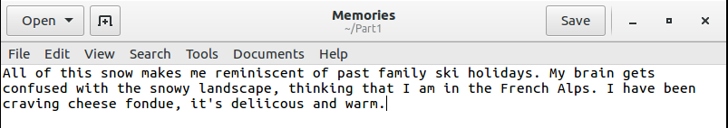

* Ask your lecturer if you need help.
* Give around an 8 line discussion for each of these editors, discussing how to create, add lines, save, …
* Do not forget to use the **pwd**, **ls**, **ls –l** commands where appropriate.

**Question 4**

*Examine the operators of pipe, redirection and append.*

Note: As with all questions, you do not need to cut&paste and place everything displayed on the terminal to the screen. You need to be selective, and show the appropriate information to show your understanding of a concept or to prove you have something working.

Exercise (**not** part of the assignment)

* Open the terminal.
* Go to the Part1 directory.
* Type **echo This is a test** to display “This is a test” on the screen.
* Type **man pwd > hold1**. The information displayed on the screen by the man command is redirected to the file hold1. Check this file by using **ls**, **ls –l** and **cat hold1**.
* Type **cat hold1 | more** to pipe or forward the information output by the cat command to a different program called more. The more program will take the information sent to it and allow it to be displayed page by page on the screen.

*NOTE:*

*The* ***|*** *operator is for pipes. The* ***>*** *operator is for the redirection to a file (the original contents of the file are cleared 🡪 destructive 🡺* ***CAUTION****). The* ***>>*** *operator is for append (redirect but add to the end of a file 🡪 non-destructive).*

**Your question (this is the assignment question)**

* Clearly illustrate your understanding of the **|**, **>**, and **>>** operators with your own examples. Include the files you created in part 3. **Very clear descriptions required**.
* **| pipe**

The output can be “piped”, or sent, to another screen, eg “|more”.

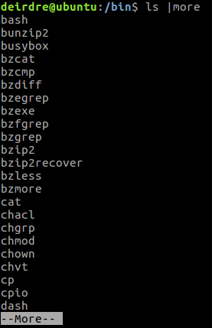

* **> redirection**

Can be very dangerous as it is destructive. Information displayed is redirected to the specified new file.

* **>> append**

Rather than delete a file, it opens it and appends it, adding extra information to the end of the file.

**Assessment 2 Details**

* Assessment 2 (which is worth 30%) will be mainly formed by week by week labs completed and submitted each week in class (weekly demonstration required). This enables giving you regular feedback.
* You must **demonstrate** some part of the work completed today in lab class to your lab lecturer.
* Submit **today’s** completed questions **on Blackboard**. Ask your lab lecturer where to submit on Blackboard.

**Exercise (Not part of the Assignment)**

* Open the terminal.
* Go to the Part1 directory.
* Remove 2 directories that you have created using the **rmdir** command.
* Confirm that they are removed using **ls**.